What is Docker, container and containerization ?

A container is an executable package with all the dependencies and other softwares such as jdk so that it can run in its own isolated environment. And it is independent of the OS and hardware configurations. And these container runs in an environment provided by the docker called Containerization.

While this is not possible in the monolithic architecture bcoz such application require separate environment which contains JDK and need to be run in separate server and depends on OS and hardware.

Docker is responsible to create containers of our webapp which is called docker images. It not only create docker images for webapps but also for existing applications like mysql and many other . Docker contains Docker server / Host which is responsible for creating the images and also maintaining them. The docker generates the image through CLI command line interface provided by the docker. Where these commands are passed to Docker server to generate images

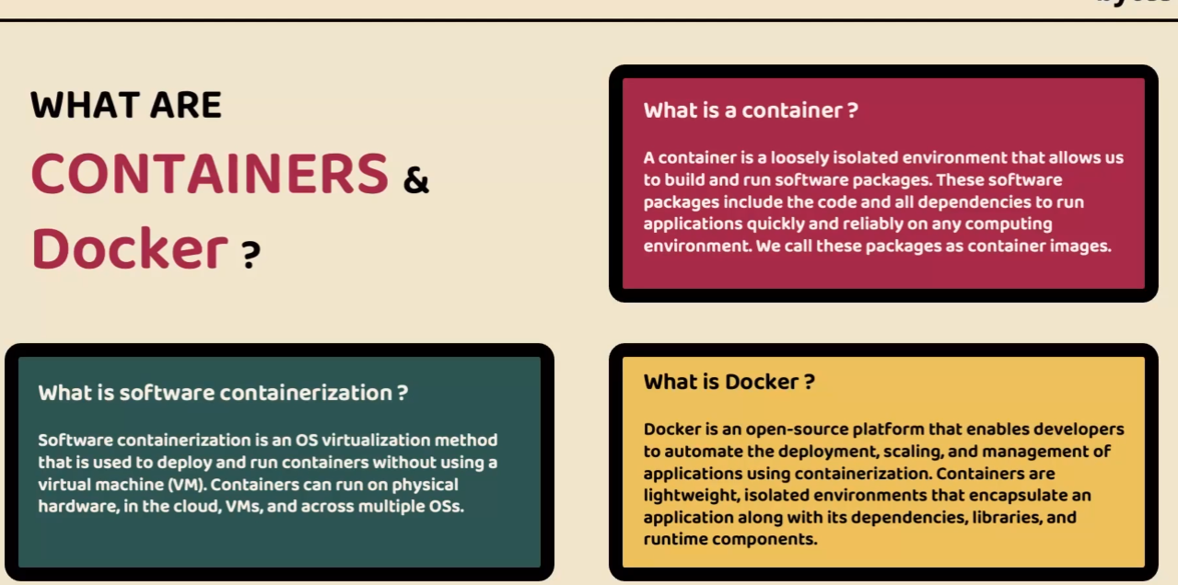

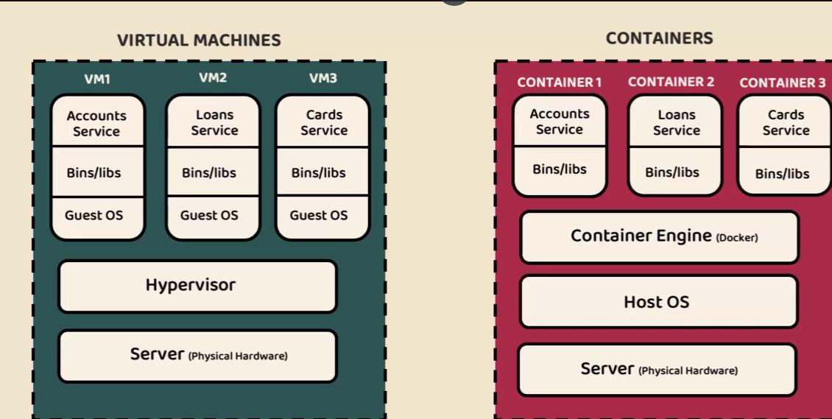

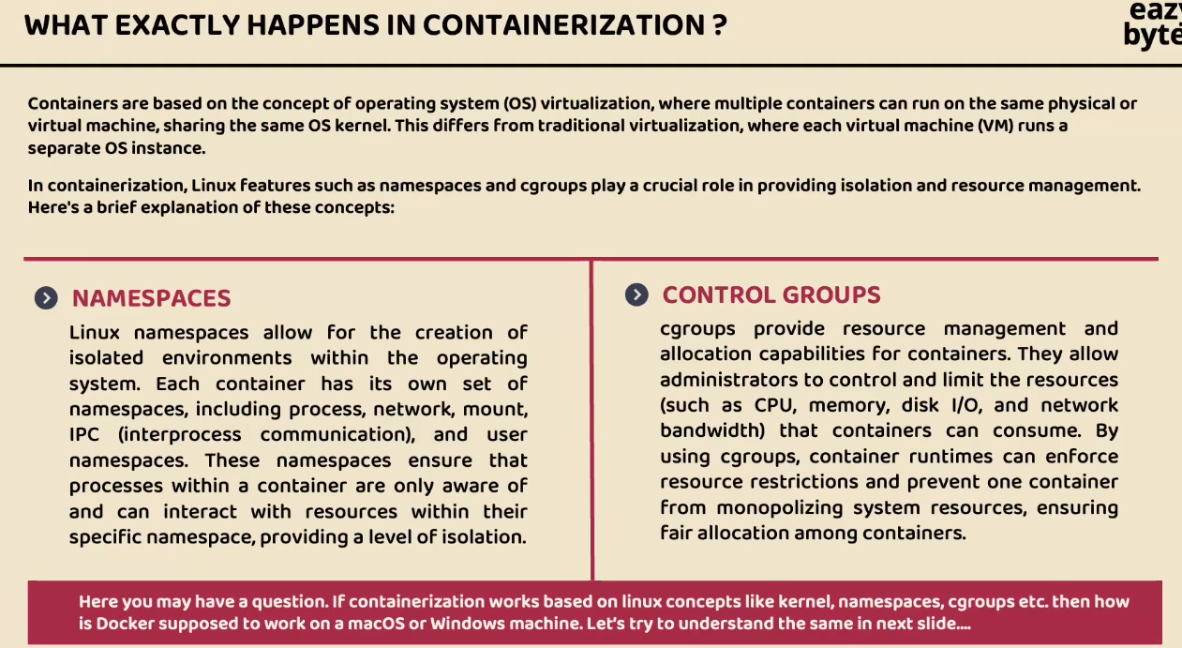

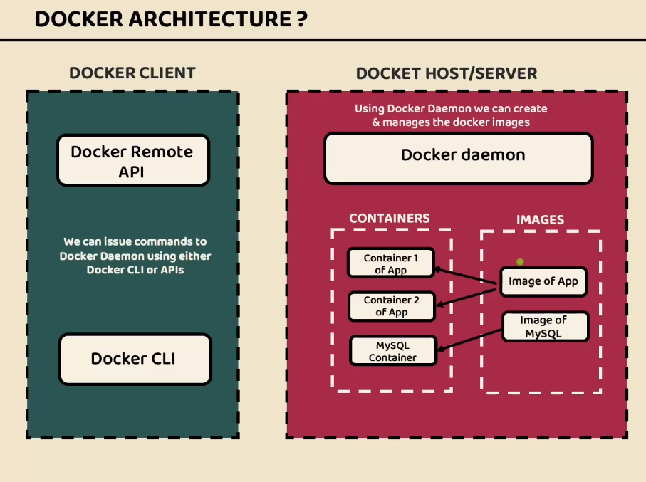

Docker also provide with its own Docker hub/ registry so where we can push the new images and download the same on different machines in this way portability issue is resolved.

Download docker desktop from official website. On the official web site itself we have login option where it will take you the Docker hub/ registry

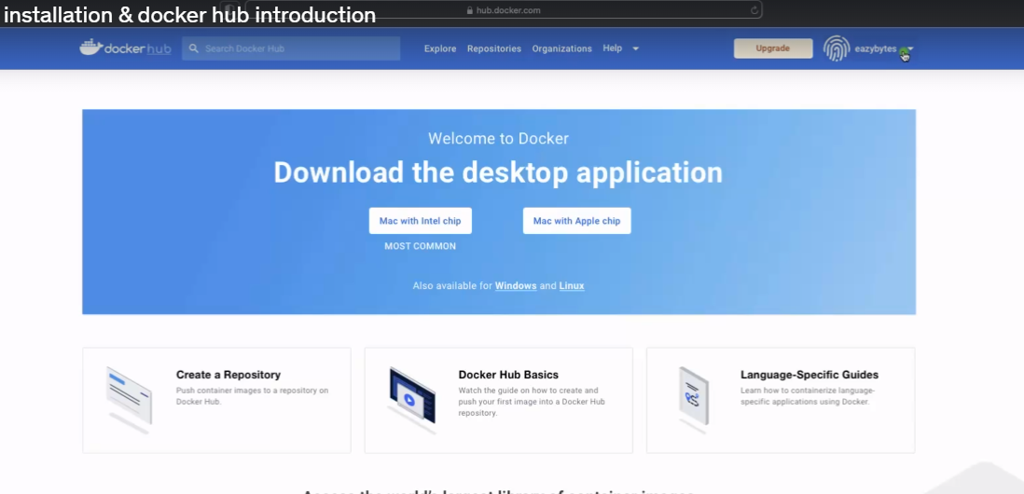

Where you can create your own repository and store all the docker images

In this course the username is eazybytes

Docker hub has many third party app images as below

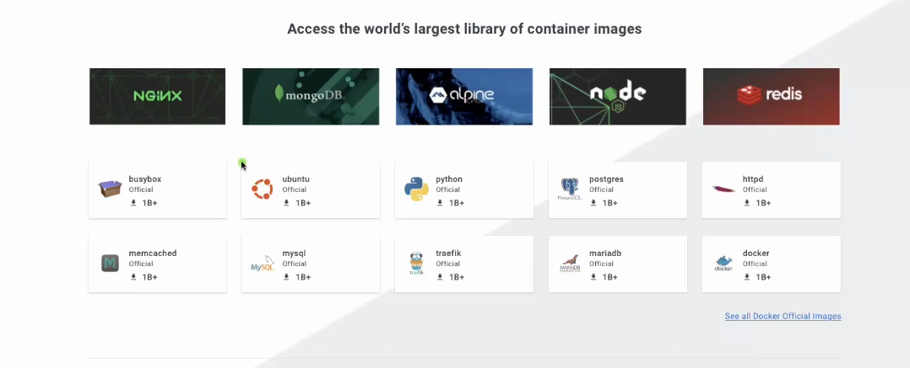

After docker installation on local system a docker icon will start appearing click on icon you will options like dashboard. Then click on dashboard then you can see below application also called as Docker desktop which contains all the images and containers as below

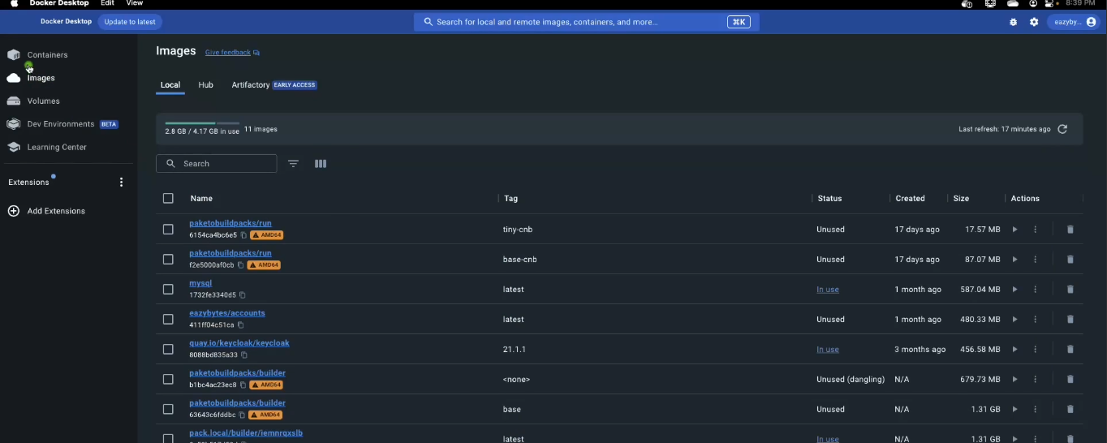

Open command prompt and check for the docker version

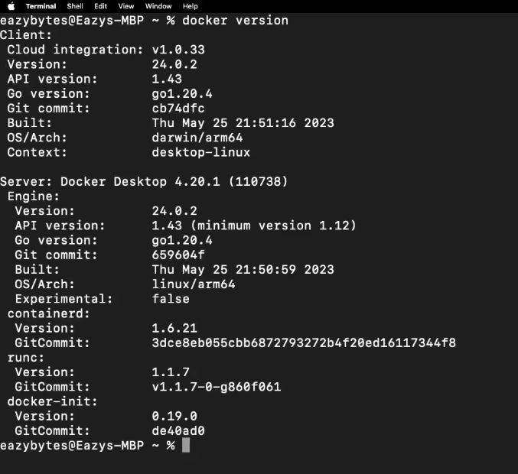

Now once everything is set we can start generating our microservices images this can be generated by using 3 ways

1. Docker file 2) Build Packs 3) Google Jib

Docker file :

First lets add a packaging

tag to generate as jar file in pom.xml

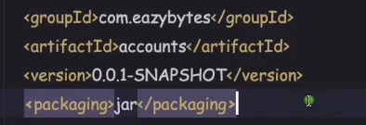

We can create jar using maven commands in terminal first install maven and setup in environment variables

Mvn clean install

Jar generated is called fat jar bcoz it contains all the dependencies required for the application. Except jdk that will have to specify in docker file

Now you can run this jar using command java -jar packagename.jar.

This knowledge is required for creating a docker file.

Now lets create a docker file. File name has to be “Dockerfile” without any extension

Docker file contains instructions to generate docker image.

Very first instruction is JRE required to run the image as images will run in its own isolated environment. Now this JRE is already a docker image in docker hub so we can just use it by specifying it in docker file. We can instruct docker by adding From command

Openjdk is image name and 17-jdk-slim is a tag name. its available in docker hub as below

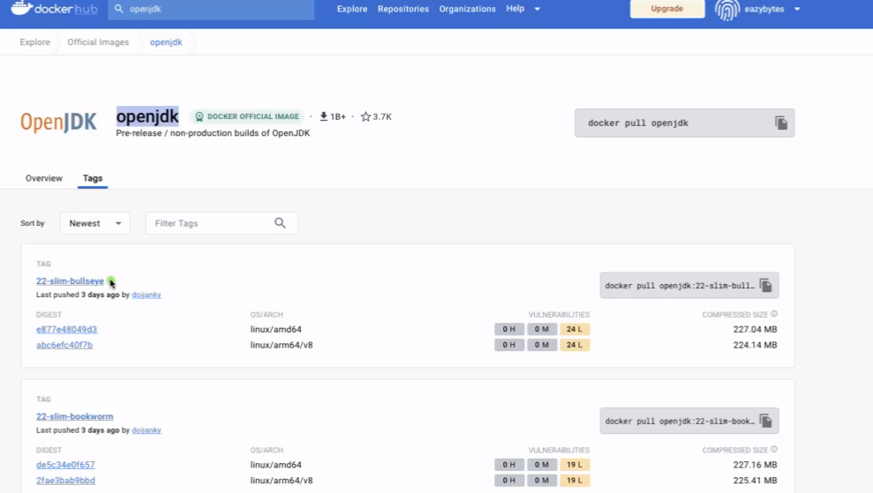

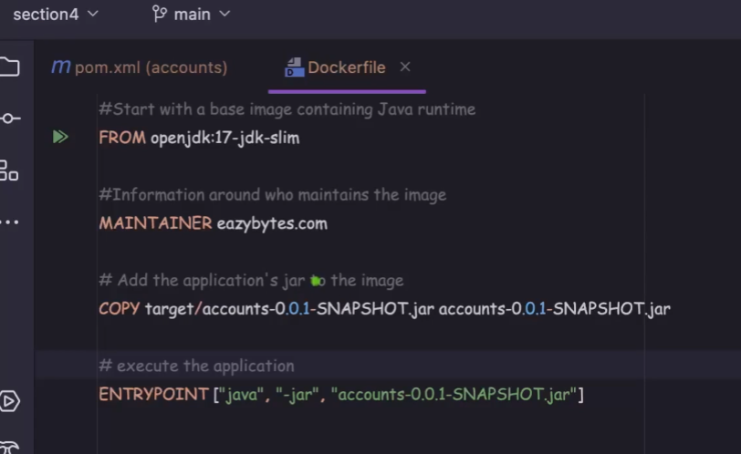

Now copy command will copy the app.jar from target folder and creates an docker image you can give same name or some othr name

To generate a container we need to have Entrypoint command. It takes an array of string usually an command to run this jar

Now to generate a docker image we need to go to location where we have created Dockerfile and then in command prompt docker build command needs to be executed.

docker build . -t eazybytes/accounts:s4

-t stands for tag name that we are going to provide for the image

Tag name we need to follow like “username/aapname:version”, username is docker hub username

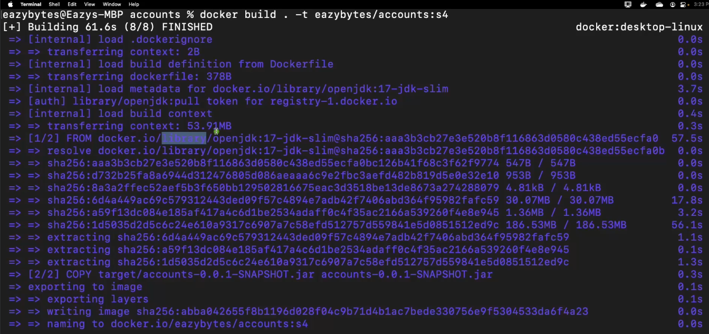

You can check docker images by command docker images

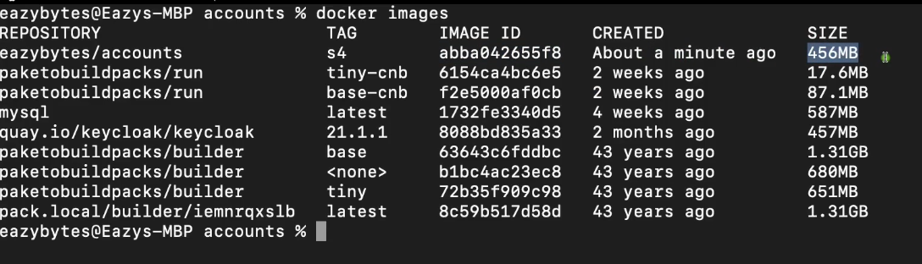

Then you inspect this image whether all the provided 3rd party dependencies are proper or no like jdk 17 etc

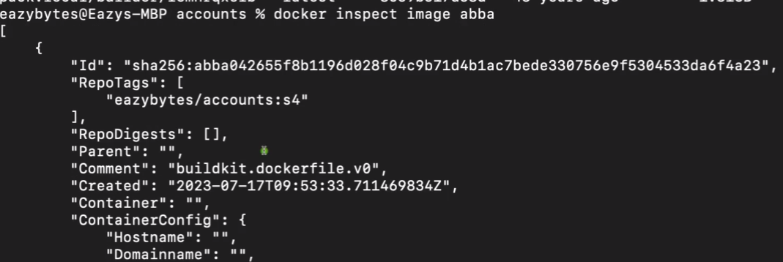

abba is first 4 character of image id

You can also check in Docker desktop search for name

Now to create the containers of the image we need to run the below command

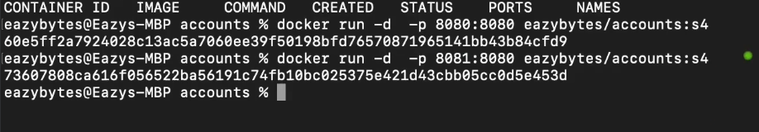

Two containers are created and running at port 8080 and 8081 respectively

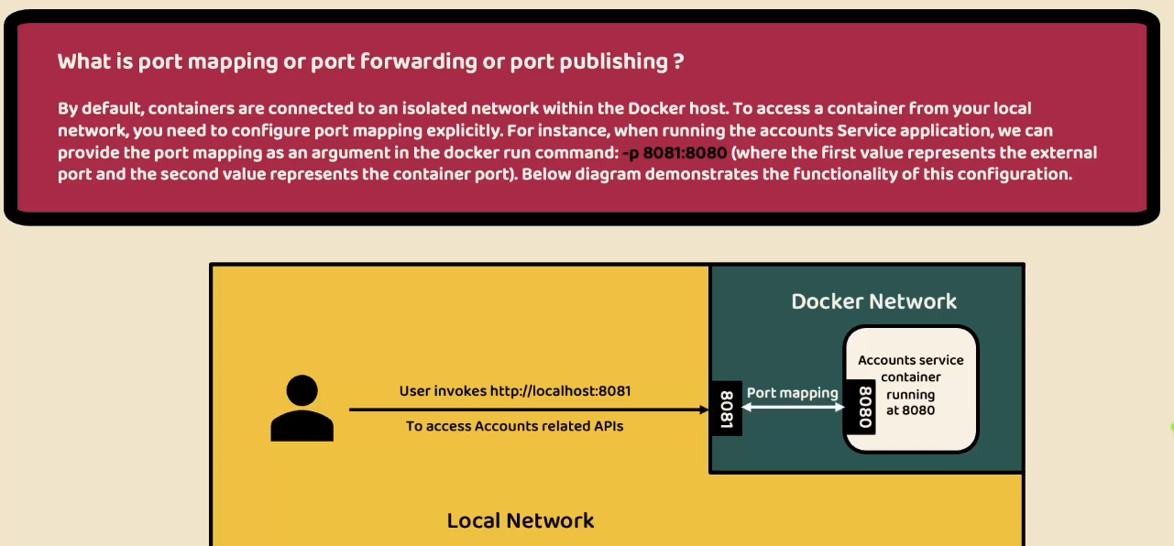

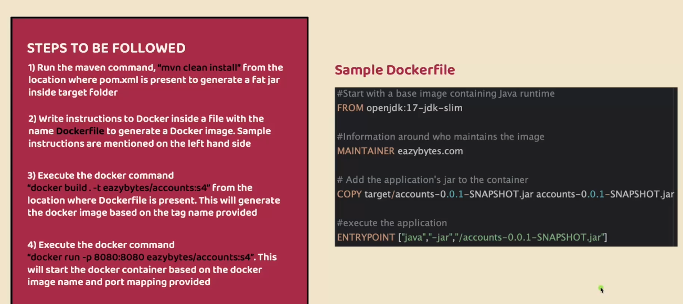

Disadvantages of docker file

To write a docker file we need to be expert in Docker concepts and commands as Devops are involved

We need to created a docker file for every individual microservice

Hence there are readily available tools to generate the docker images one such tool is google jib

Google Jib website - <https://github.com/GoogleContainerTools/jib>

Google jib works only on Java application for documentation goto maven

We need to add plugin related to google jib